# Serenity Rogers 6/15/24

# CS 255 System Design Document Template

This template lays out all the different sections that you need to complete for Project Two. Each section has guidance to prompt your thinking. You will need to continually reference the interview transcript as you work to make sure that you are addressing your client’s needs. There is no required length for the final document. Instead the goal is to complete each section based on what your client’s needs are. Remove this note when you are finished, and replace all bracketed text with the relevant information.

## UML Diagrams

### UML Use Case Diagram

### UML Activity Diagrams

*Customer Use Case UML Activity Diagram*

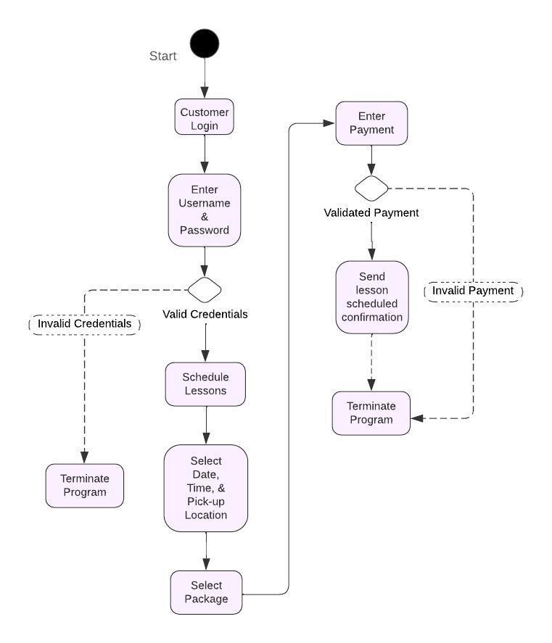

*Driver Use Case UML Activity Diagram*

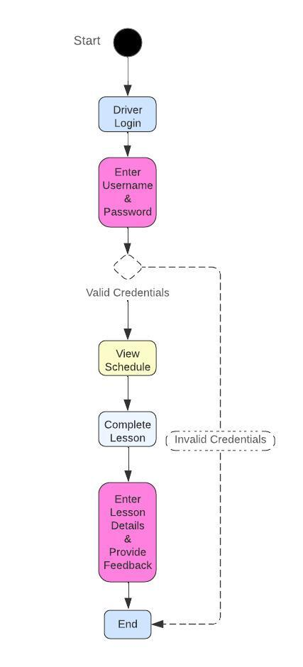

### UML Sequence Diagram

*Customer UML Sequence Diagram*

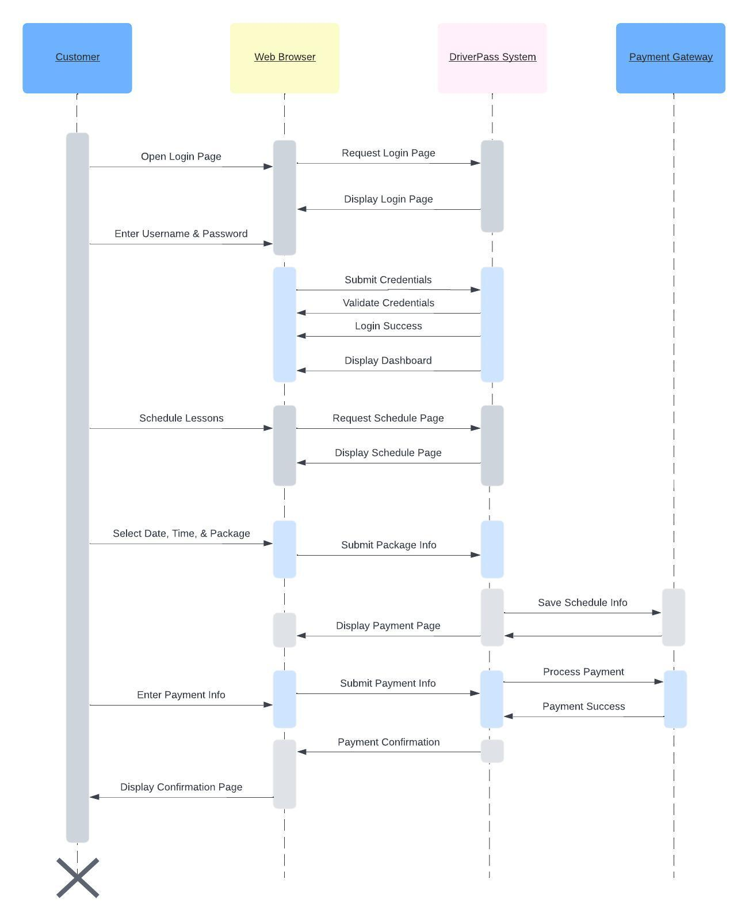

### UML Class Diagram

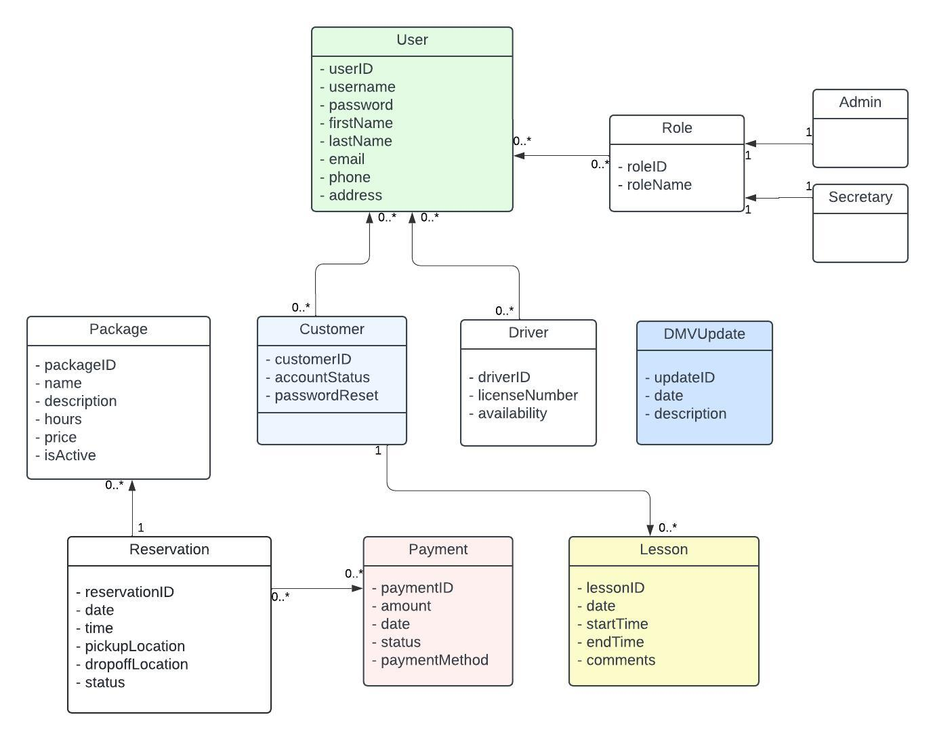

## Technical Requirements

Based on the diagrams created for the DriverPass system, there are several technical requirements:

1. A high-performance web server must be implemented to host the web application, a database server for managing the database, and a backup server for data backup and recovery.
2. Office staff must be provided desktop or laptop computers. Smartphones and/or tablets with internet access should be available for drivers to use on-the-go. Customers should be able to access the system using either a computer or mobile device.
3. Operating systems, database management systems, web application framework, development tools, web server software and security tools should be put in place for software requirements.
4. Cloud services, network infrastructure, backup and recovery, and integration services should be utilized to uphold infrastructure requirements.

Setting up robust hardware and setup for the DriverPass system will ensure high performance, reliability, and security. In order to facilitate future growth and include comprehensive backup and recovery plans to protect data integrity, the infrastructure should be scalable to accommodate future growth. Using web application frameworks, databases, and cloud services will enable efficient development, deployment, and management of the system.